**Environmental Economics: Problem Set 1**

**Group Member: Shuyang Hou**

**Part I. Economic efficiency.**

1. Suppose that a policymaker can choose Policy option A or B. There are five people in the economy whose consumption of a single composite good under A is (2, 5, 7, 13, 15), and under B is (12, 9, 4, 18, 22)

True or False: Moving from allocation A to B is a Pareto improvement.

False. Because transferring from the allocation A toward B will bring about loss to the third individual (7 reduced to 4).

1. (Continuing) True or False: Moving from allocation A to B in the above example is a Kaldor-Hicks improvement.

True, due to the fact that the sum of allocation B (65) is bigger than the sum of the allocation A (42), while the Kaldor-Hicks improvement itself means “a larger pie”.

1. True or False: Any change in resource allocation that is a Pareto improvement is also a Kaldor-Hicks improvement.

True. If a change in resource allocation leads to Pareto improvement, then everyone in this system must gain some benefits (or maintain the original level, but at least one individual will gain benefits), which will certainly increase the total “pie” (Kaldor-Hicks improvement).

1. Consider an economy with two people, Donald and Melania, and one good, yachts, denoted y. There are 4 yachts total in the economy. Both people have the same utility function Ui ( y ) = y1/2. (Assume yachts can be consumed in continuous measure, not just integers.)

True or False: An allocation in which Donald has 4 yachts and Melania has 0 yachts is Pareto efficient.

True. Since there does not exist any strategy to improve the state of Melania without harming Donald’s benefits. Actually, any allocation is Pareto efficient as long as the sum of yachts is exactly 4.

1. Now suppose that Donald and Melania live in an economy with two goods, yachts and condos, denoted c. There are 4 yachts and 10 condos in the economy. Both people have the same utility function, Ui ( y, c ) = y1/2c1/2.

True or False: An allocation where Donald has 3 yachts and 10 condominiums (and Melania has 1 yacht and 0 condos) is Pareto efficient.

True, due to the fact that the amount of yacht Donald possesses (3) plus the amount of yacht Melania possesses (1) is equal to the sum (4), and the same for the condos (10 + 0 = 10), which means there does not exist any possibility to enhance either one without harming the other.

**Part II. Externalities.**

1. There are 10 farms along a river. Each uses fertilizer that causes run off that lowers the profits of a downstream fishery by adding nitrates to the water. The amount of runoff (nitrates that reach the river) per ton of fertilizer used depends on the slope of the land and the proximity of fields to the river. Half of the farms are steeper and closer, so they produce 1 unit of nitrates in the water for every ton of fertilizer. Half are farther and flatter and producer 0.1 units of nitrates in the water for every ton of fertilizer. Suppose that the damage done to the fishery is $4 for every unit of nitrates in the water.

True or False: Because of the externality, the market for fertilizers is not Pareto efficient. Imposing a tax of $4 per ton of fertilizer paid by all farmers would correct this market failure and ensure that the allocation of fertilizers was Pareto efficient.

False. For the farms closer to the river, every ton of fertilizer will produce 1 unit nitrates, which is equal to $4 externality; While for the farms far from the river, every ton of fertilizer will only produce 0.1 unit nitrates, which is equal to $0.4 externality. The tax of $4 per ton of fertilizer is too high for the farms far away.

1. Many farmers regularly feed their livestock antibiotics (even while healthy) in order to reduce infections in their populations. The widespread use of antibiotics can accelerate the evolution of bacteria that are resistant to antibiotics, however, which can increase the vulnerability of livestock in the future throughout the country and the world.

True or False: An individual farmer’s use of antibiotics constitutes an externality that implies a market failure.

True. If we analogize bacteria as air pollution, the act of feeding livestock antibodies irrationally thus accelerating the evolution of bacteria is analogue to the act of emitting exhaust gas without purifying it thus causing heavier air pollution.

**Part III. Pigouvian tax algebra problem.**

The Pigouvian prescription says to fix an externality by setting a tax rate equal to marginal damages at the optimal quantity. When marginal external damages are constant, the “at the optimal quantity” part is redundant. But, when marginal external damages are changing with the quantity of the good, you have to figure out the right quantity to determine the right tax rate. This problem illustrates this with an algebra example.

Consider a market where total private benefits are equal to $TB = 50 Q − Q^{2}$. Total

private costs are $TC = 12.5 Q + 0.25Q^{2}$. Total external damages (costs) are equal

to $TED = 2.5Q^{2}$.

1. Graph this market, showing the supply curve, demand curve, private equilibrium and optimal allocation.* (Upload an image of your graph with your answers. You can draw this by hand and take a picture. Label key values.)

From the TB, TC, and TED value, we can derive MB, MC, and MED by differentiating with regard to Q :

$$MB = 50 − 2Q$$

$$MC = 12.5 + 0.5Q$$

$$MED = 5Q$$

Thus the Social Marginal Cost is:

$$SMC = MC + MED = 12.5 + 5.5Q$$

Private equilibrium occurs at the state when MB is equal to MC. By solving :

$$MB = MC$$

We get the quantity at private equilibrium :

Optimal allocation occurs at the state when MB is equal to SMC. By solving :

$$MB = SMC$$

We get the quantity at private equilibrium :

$$Q^{∗}= 5$$

The graph of supply curve, demand curve are shown in figure below (Fig.1) :

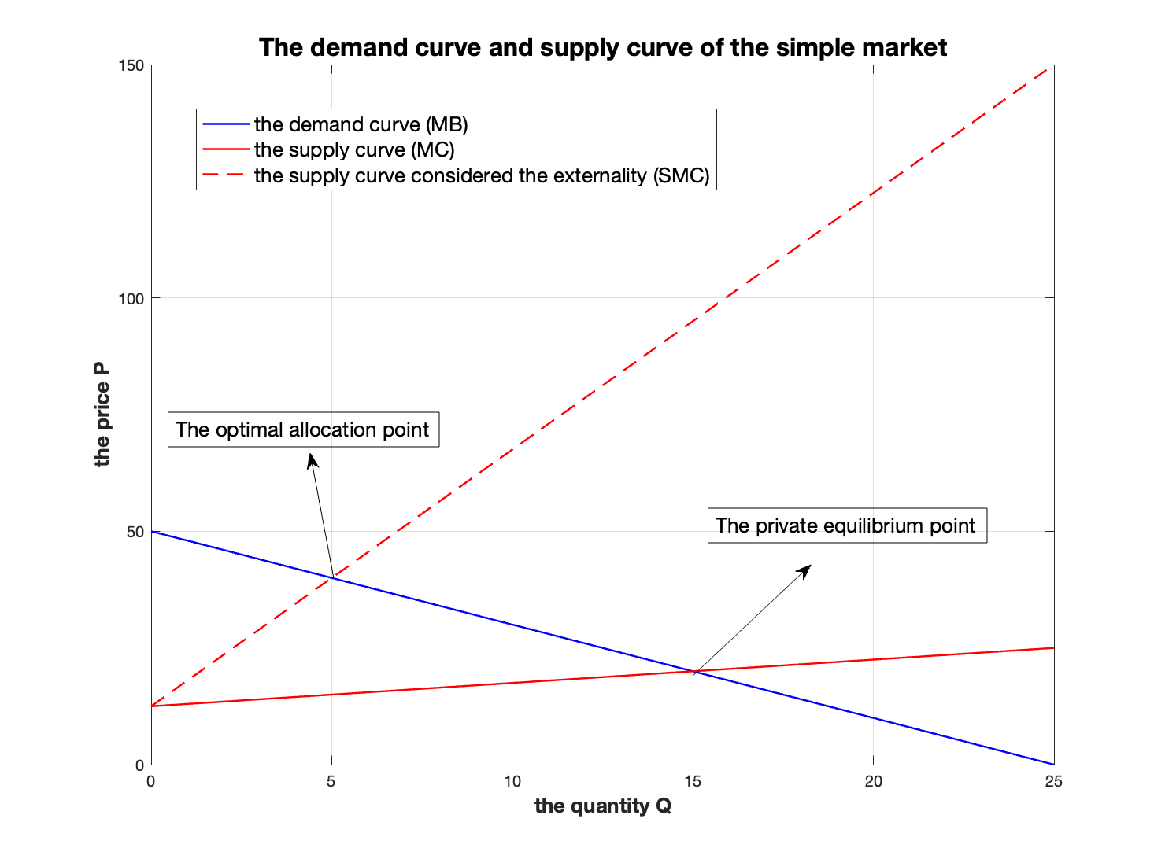

**Fig.1 : The demand curve and supply curve of the simple market**

1. What is the optimal tax rate on the good?

An optimal tax is equal to the MED at the optimal allocation quantity :

$$Tax = {\left.MED\right|}_{Q^{∗}} = 5Q^{∗} = 25$$

**Part IV. Optimal taxes and deadweight loss.**

The Pigouvian tax does not directly depend on the slope of supply and demand, which means that the tax does not depend on how big the quantity response will be to the imposition of a tax. But, does this mean that the quantity response is irrelevant? This problem provides an illustrative example.

Consider a market where total private benefits are equal to $TB = 660 Q − Q^{2}$. Total

private costs are $TC = 66 Q + 0.5Q^{2}$. Total external damages (costs) are equal to $TED = 66 Q$.

1. What is the optimal tax?

From the TB, TC, and TED value, we can derive MB, MC, and MED by differentiating with regard to Q :

$$MB = 660 − 2Q$$

$$MC = 66 + Q$$

$$MED = 66$$

We notice that the MED is constant (i.e. irrelevant to Q), so no matter where the optimal allocation is, the optimal tax value is equal to 66 :

$$Tax = 66$$

1. What is the change in quantity that results from introducing the tax?

Private equilibrium occurs at the state when MB is equal to MC. By solving :

$$MB = MC$$

We get the quantity at private equilibrium :

Optimal allocation occurs at the state when MB is equal to SMC. By solving :

$$MB = SMC = MC + MED$$

We get the quantity at private equilibrium :

$$Q^{∗}= 176$$

So the change in quantity is :

$$∆Q =Q_{m} − Q^{∗} = 22$$

1. Calculate the welfare gain from introducing the optimal tax.

The Social Welfare is defined as:

$$SWF = TB − ( TC + TED ) = 528Q − 1.5Q^{2}$$

So the SWF at optimal allocation is :

$${SWF}^{∗} = 46464$$

The SWF at private equilibrium is :

$${SWF}_{m} = 45738$$

Thus, the welfare gain G from introducing the optimal tax is :

$$G = ∆ SWF = {SWF}^{∗} − {SWF}_{m} = 726$$

Now, suppose that the MB curve was much more vertical (less elastic). Specifically,

suppose that $TB = 2244 Q − {5Q}^{2}$.

1. What is the optimal tax now? (Think to yourself: is this different than your answer in question 10? Why or why not?)

Similarly, the optimal tax is equal to 66 as well, due to the fact that the MED is constant.

$$Tax = 66$$

1. What is the change in quantity that results from introducing the tax? (Think to yourself: is this different than your answer in question 11? Why or why not?)

Now according to the new scenario, the MB is :

$$MB = 2244 − 10Q$$

Then do the same calculation as in the problem 11, we get :

$$Q_{m} = 198$$

$$Q^{∗}= 192$$

So the change in quantity is :

$$∆Q =Q_{m} − Q^{∗} = 6$$

1. Calculate the welfare gain from introducing the optimal tax. (Think to yourself: is this different than your answer in question 12? Why or why not?)

Do the same calculation as in the problem 13, we get :

$$SWF = TB − ( TC + TED ) = 2112Q − 5.5Q^{2}$$

$${SWF}^{∗} = 202752$$

$${SWF}_{m} = 202554$$

Thus, the welfare gain G from introducing the optimal tax is :

$$G = ∆ SWF = {SWF}^{∗} − {SWF}_{m} = 198$$

Think to yourself: what does this example suggest about the relationship between the welfare gain (elimination of deadweight loss) and the slopes of demand and supply?

The steeper the slopes of the demand or supply curve, the smaller the amount of welfare gain by setting optimal tax.

**Part V. Incidence**

Consider a market for a good X with the following equations. Total benefit is $TB = 100X − {0.25X}^{2}$. Total cost is $TC = {2X}^{2}$. The good has a total externality equal to

$TE = 2X + {0.125X}^{2}$.

1. What is the consumer surplus, producer surplus and total externality in this market when there is no tax?

$$TB = 100X − {0.25X}^{2}$$

$$TC = {2X}^{2}$$

$$TE = 2X + {0.125X}^{2}$$

And then from the TB, TC, and TE value, we can derive MB, MC, and MED by differentiating with regard to Q :

$$MB = 100 − 0.5X$$

$$MC = 4X$$

$$ME = 2 + 0.25X$$

When there exists no tax, private equilibrium occurs at the state when MB is equal to MC. By solving :

$$MB = MC$$

We get the quantity at private equilibrium :

$$X_{m} = \frac{200}{9}$$

and the price at the private equilibrium :

$$P_{m} = \frac{800}{9}$$

So, the consumer surplus $C_{s}$ is equal to : $$C_{s} = \frac{1}{2} (100 − P_{m}) ∗ X_{m} = \frac{10000}{81} ≈ 123.46$$

and the producer surplus $P_{s}$ is equal to : $$P_{s} = \frac{1}{2} X_{m} ∗ P_{m} = \frac{80000}{81} ≈ 987.65$$

The total externality E at private equilibrium is :

$$E = TE{\left.D\right|}_{X_{m}} ≈ 106.17$$

1. Suppose that a corrective tax following the Pigouvian prescription is employed. What is that tax rate?

Optimal allocation occurs at the state when MB is equal to SMC. By solving :

$$MB = SMC = MC + MED$$

We get the quantity at private equilibrium :

$$X^{∗}= \frac{392}{19}$$

An optimal tax is equal to the MED at the optimal allocation quantity :

$$Tax = {\left.MED\right|}_{X^{∗}} =2 + 0.25X^{∗} = \frac{136}{19}$$

and the price after the implementation of the optimal tax is :

$$P^{∗} = 100 − 0.5X^{∗} = \frac{1704}{19}$$

Thus, the tax rate $t_{r}$ is :

$$t_{r} = \frac{Tax}{P^{∗}} = 7.98\%$$